CHAPTER 6. The 2k experiment.

This Chapter was covered in class up to section 6.5 A Single Replicate of the 2k Design. When n = 1 then we cannot have a SSE term in the ANOVA table. There are 3 approaches to solve this situation: the Percent Contribution, the Normal Plot, the Method of Lenth. We start with **(a)** the Percent Contribution approach as shown below. The percent is obtained respect SST. Here there are indications that Factor A, C, D, and the interactions AC and AD contribute to explain the variability observed in the data.

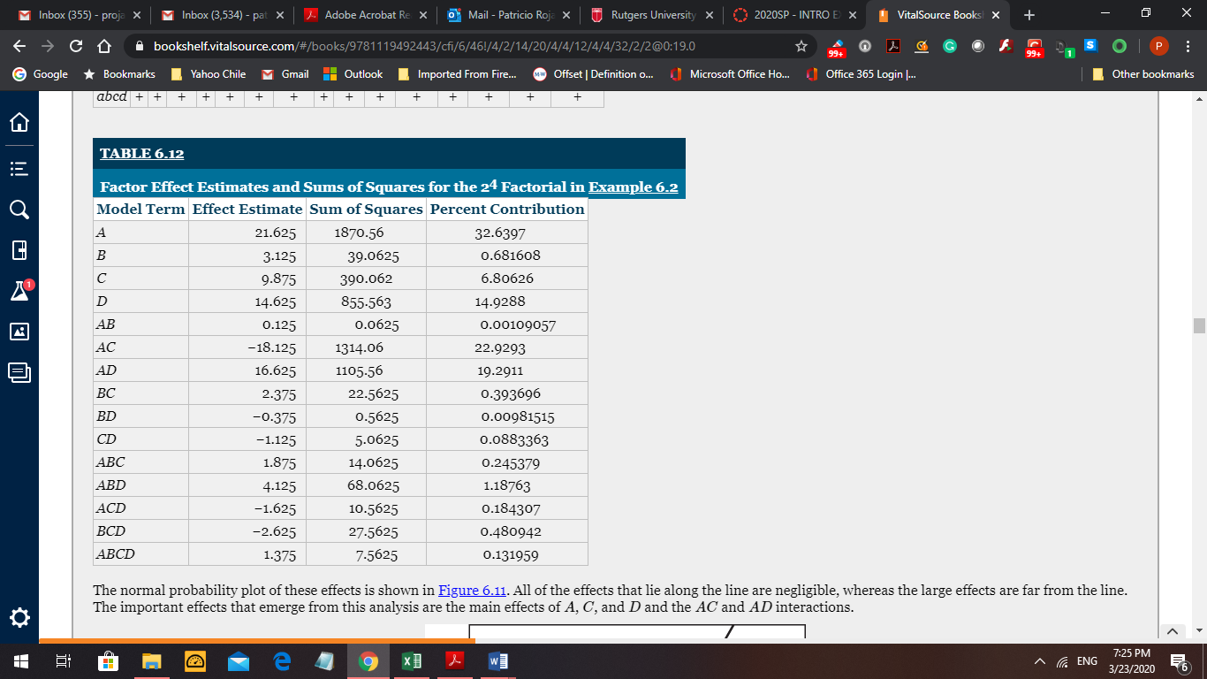

**(b)** Other method is to generate a normal plot of the estimators. Then the points that do not follow a common straight line can be identified as significant. See the plot below. The estimator of the B effect is on the line with others since μB = μ but for the A effect the relation is μA = μ + τA that is τA ≠ 0.

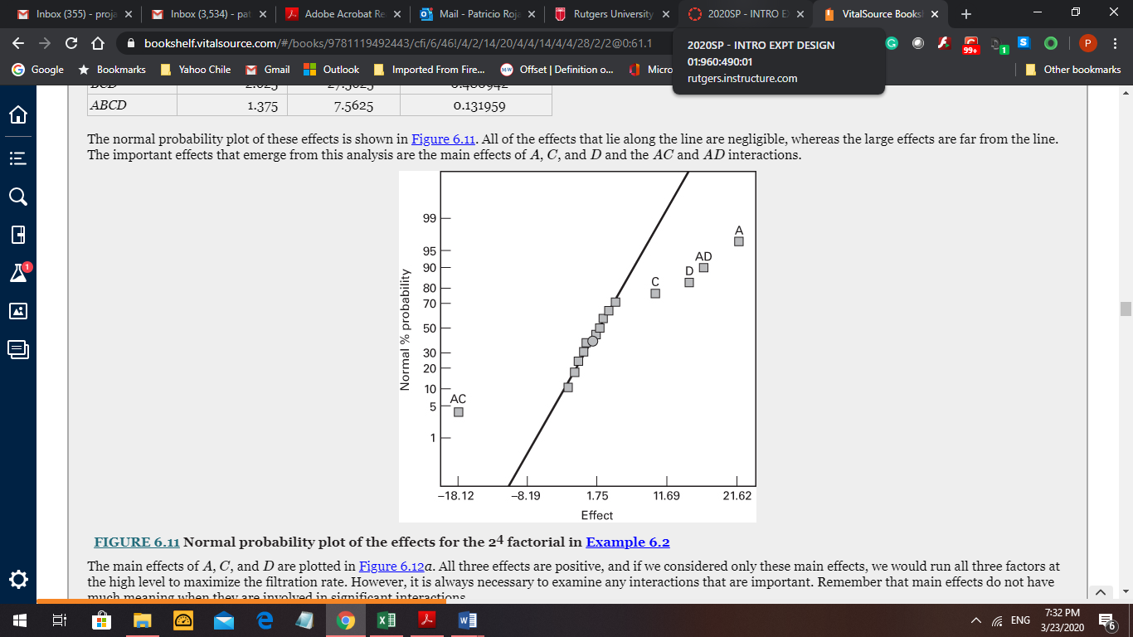

Notice that B and all the interactions containing B are not significant. Then the 24 experiment can be expressed as a 23 experiment with main factors A, C, and D, and n = 2 replications (24 = 23 * 2). The original 24 design is projected in 3 factors as a 23 design with 2 hidden replications. Also the interaction CD is not significant. This gives 8 degrees of freedom to define a SSE. The ANOVA for this reduced model is presented below. **Note:** a half-normal plot is an alternative method; use absolute value of the effects.

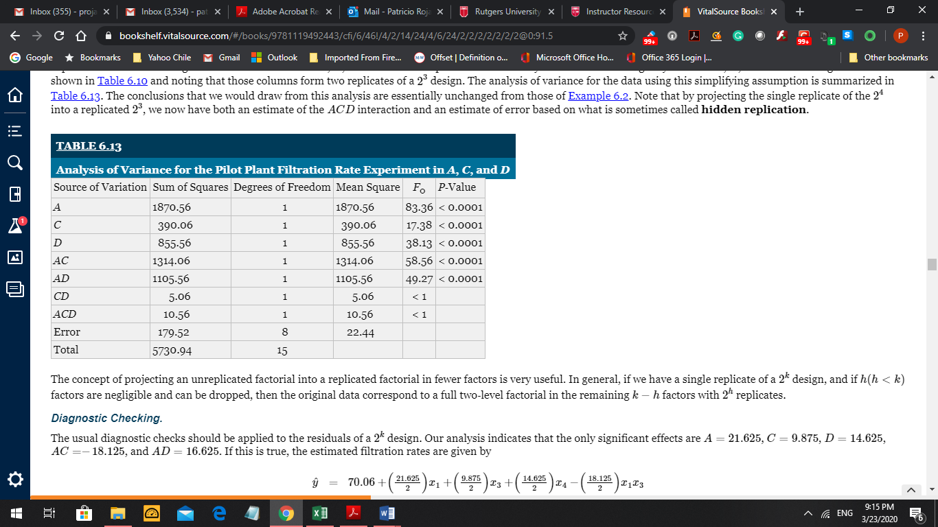

The regression equation for this reduced model is: (check Table 6.12 on Page 1)

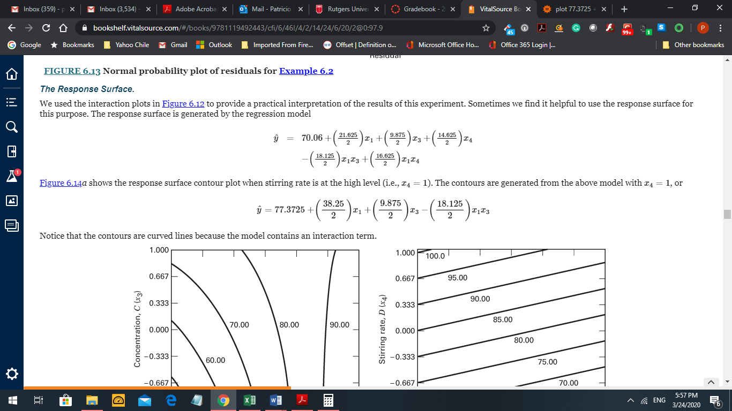

You can generate easily response surfaces and contour plots. Go to [www.wolframalpha.com](http://www.wolframalpha.com), then click on Mathematics, then select Plotting & Graphics, then select 3D Plots, and finally click on p[lot x^2 y^3, x=-1..1, y=0..3](https://www.wolframalpha.com/input/?i=plot+x%5E2+y%5E3%2C+x%3D-1..1%2C+y%3D0..3&lk=3) = and rewrite the equation using the regression coefficients determined above but with x4 = 1:

plot 77.3725 + (39.25/2) x + (9.875/2) y – (18.125) x y, x = -1..1, y = -1..1 =

Then you will get the Response Surface and the Contour Plot for the main effects A (temperature) and C (concentration) using effect D (stirring rate) at the high level (x4 = 1). The goal of the experiment is to find the factor levels than maximize the response (the filtration rate). You can use also the engineering values instead of the coded values -1 and +1 for the regression equation.

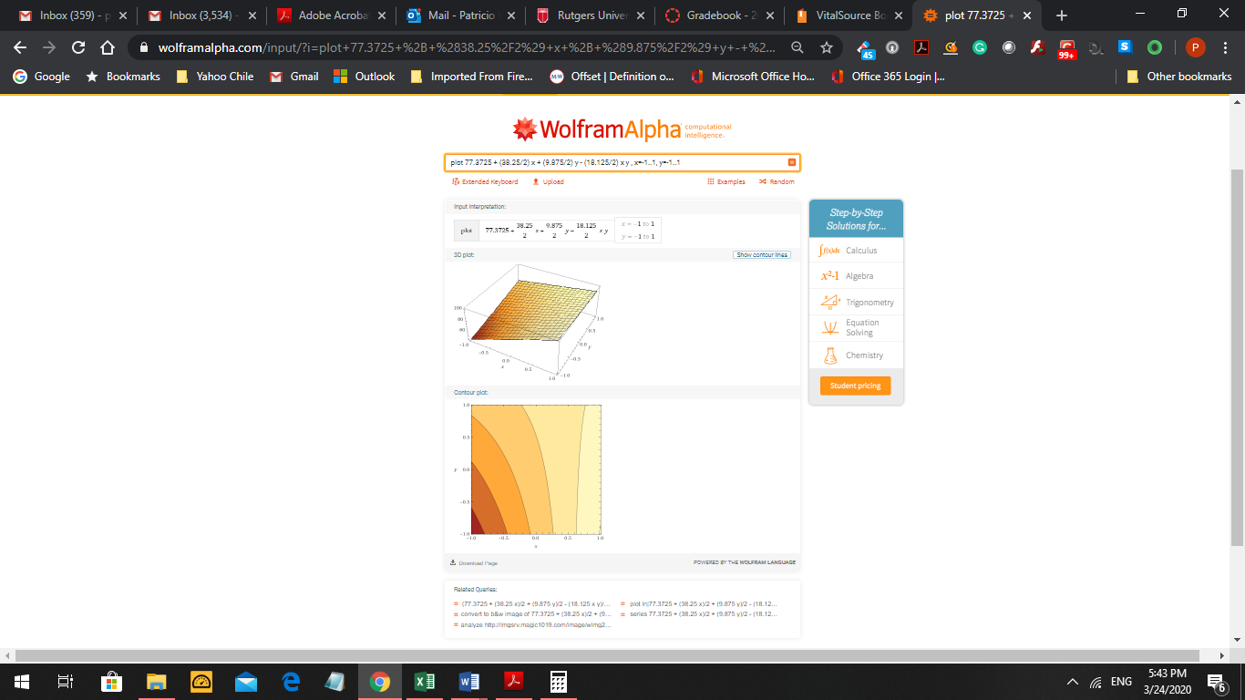

**(c)** A third method was proposed by Prof. Lenth (U. of Iowa). 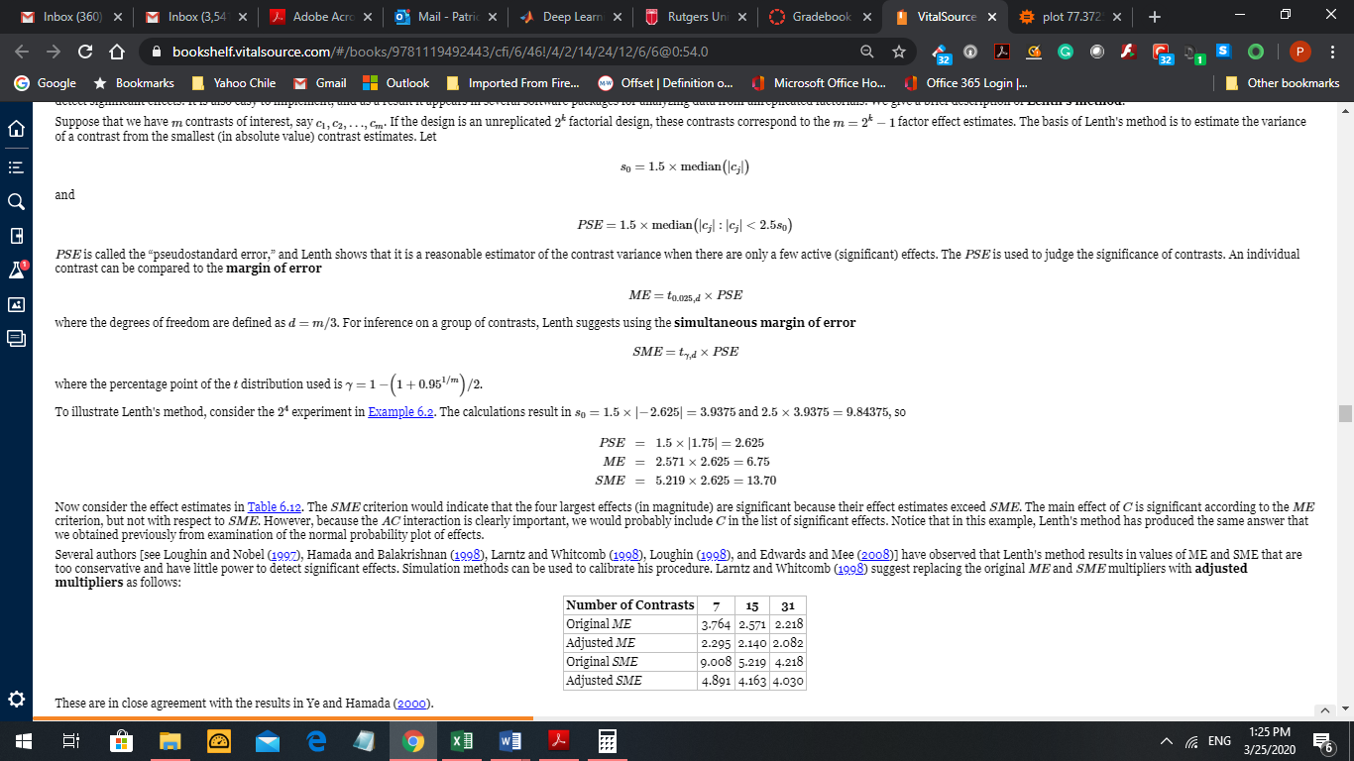

There are other methods proposed for this situation, but we cover only these three.

The last concept in this chapter refers to using not only the mean response to assess the experimental results, but also consider the dispersion effects that can be measured in case we have repetitions but not replications in each treatment combination (that is, when n=1) or in case we have replications (n>1). The goal of the experiment can be to maximize the result, or minimize the result, or get close to a target value. Competing with this objective is the concept of having a response with low variability, or in other words, a result with high precision. The first situation is described in the example below.

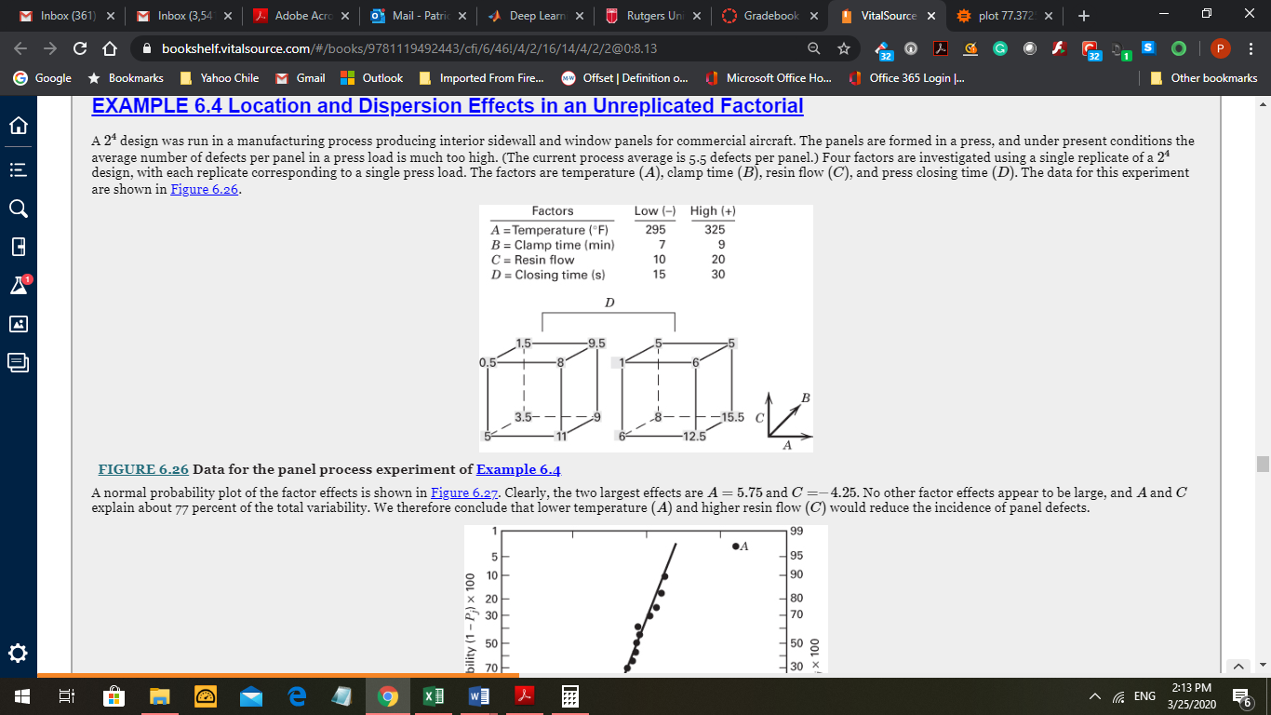

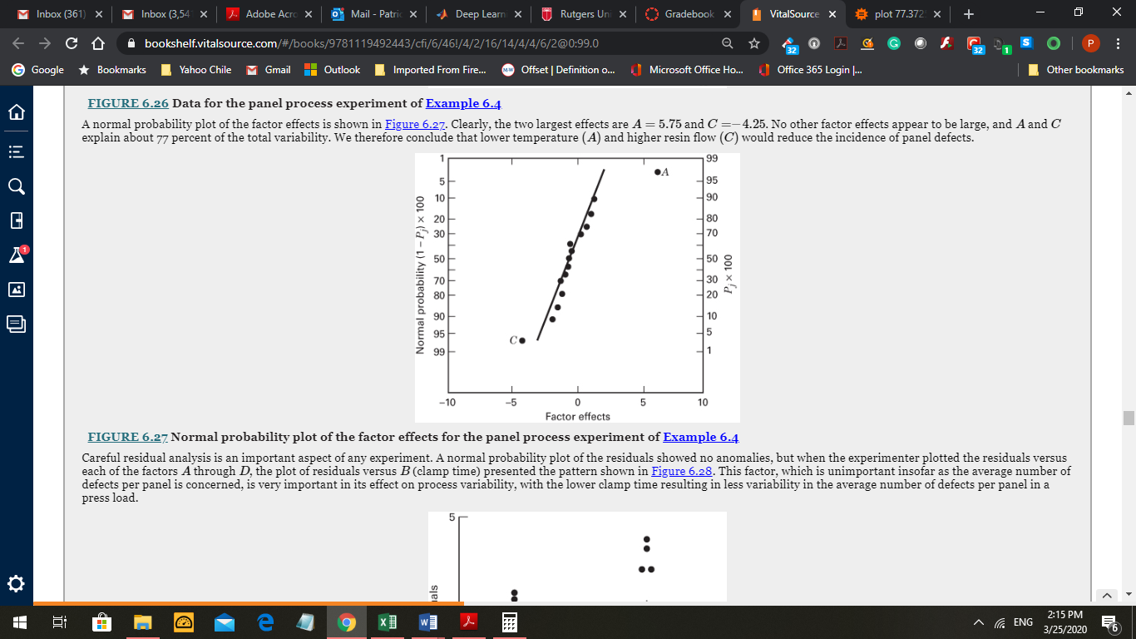

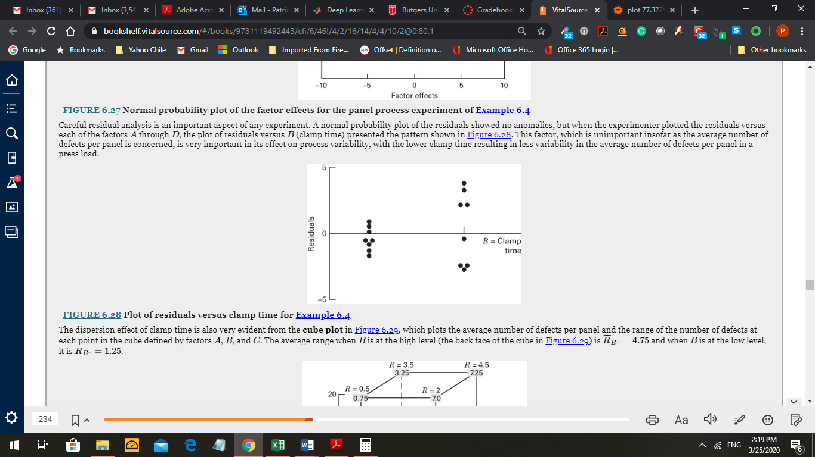

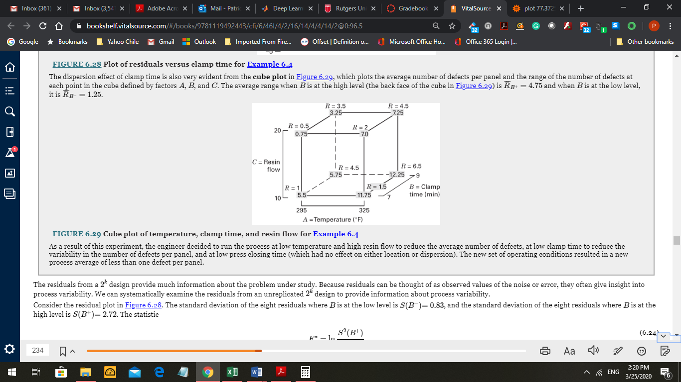

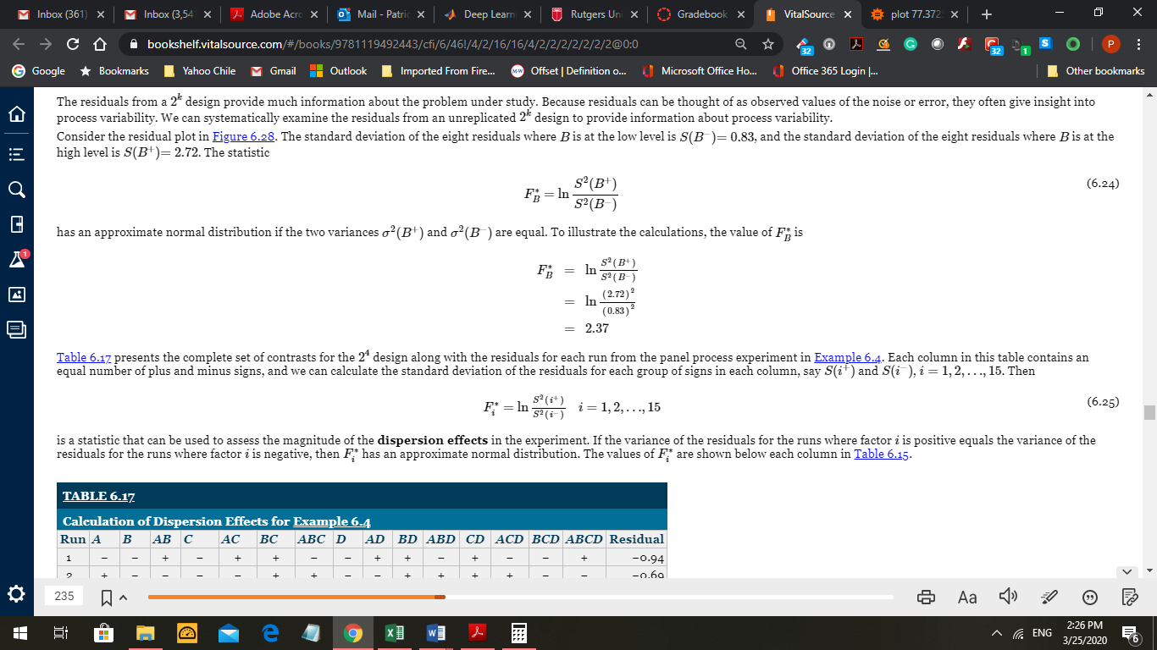

(Notice misprint above: the last line says Table 6.15 but is should say Table 6.17, below)

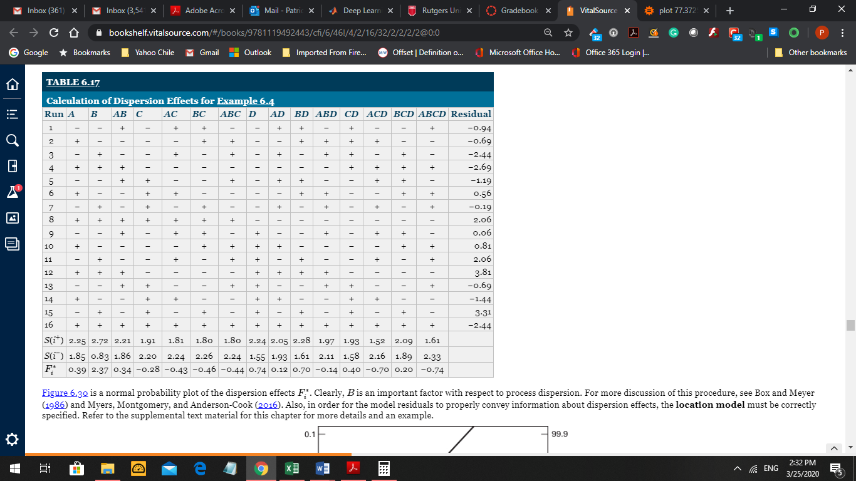

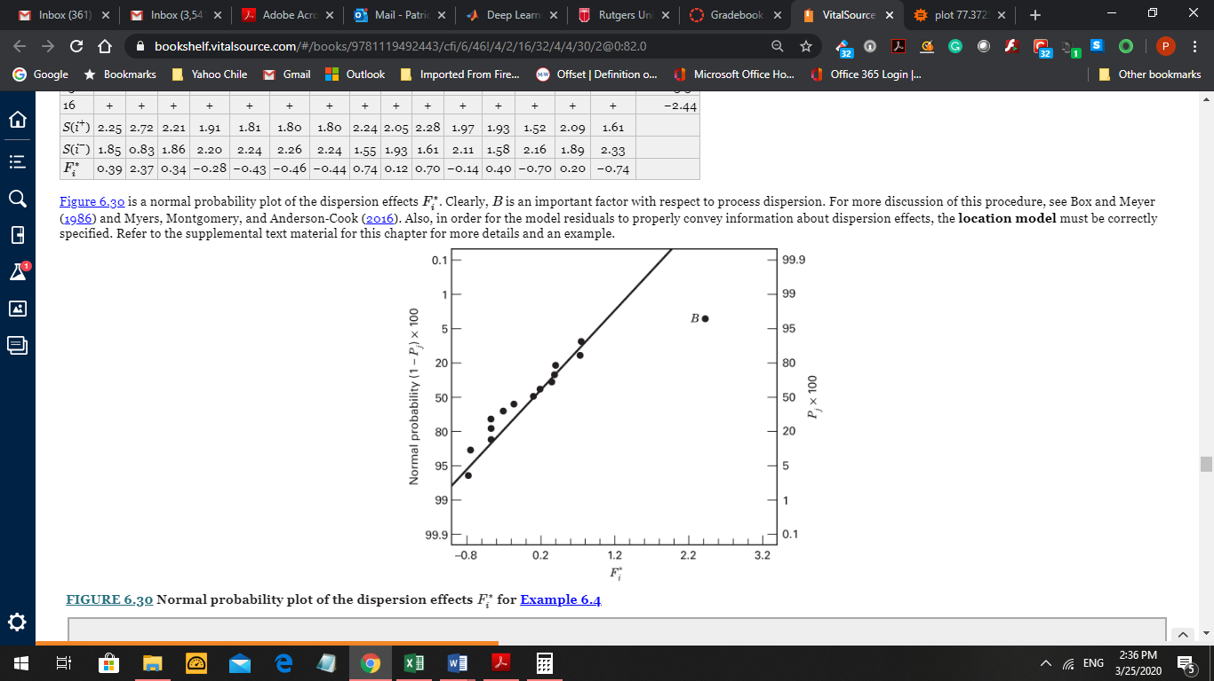

When we have replications we can assess the mean response and the variability of the results. This is presented in the double contour plot; some curves refer to the mean response close to a target value, and the straight lines referring to a measure of variability. The area in white corresponds to the best combination of treatments: mean response close to a target value and area of low dispersion.

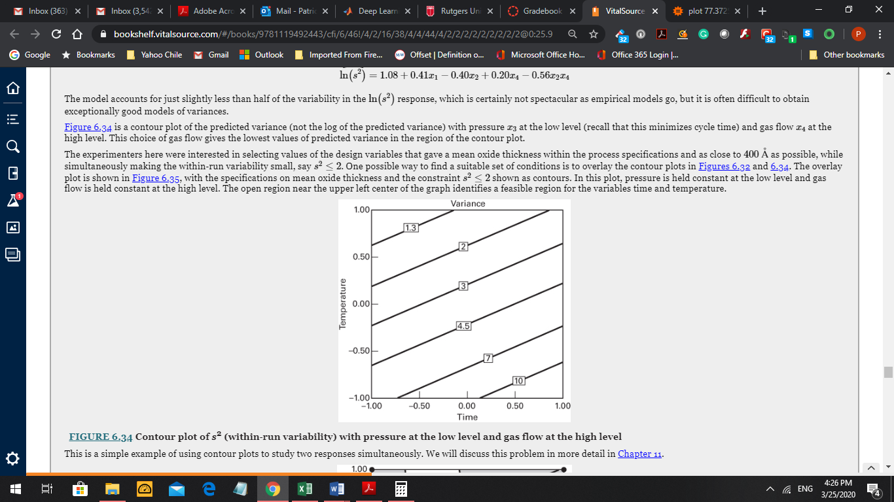

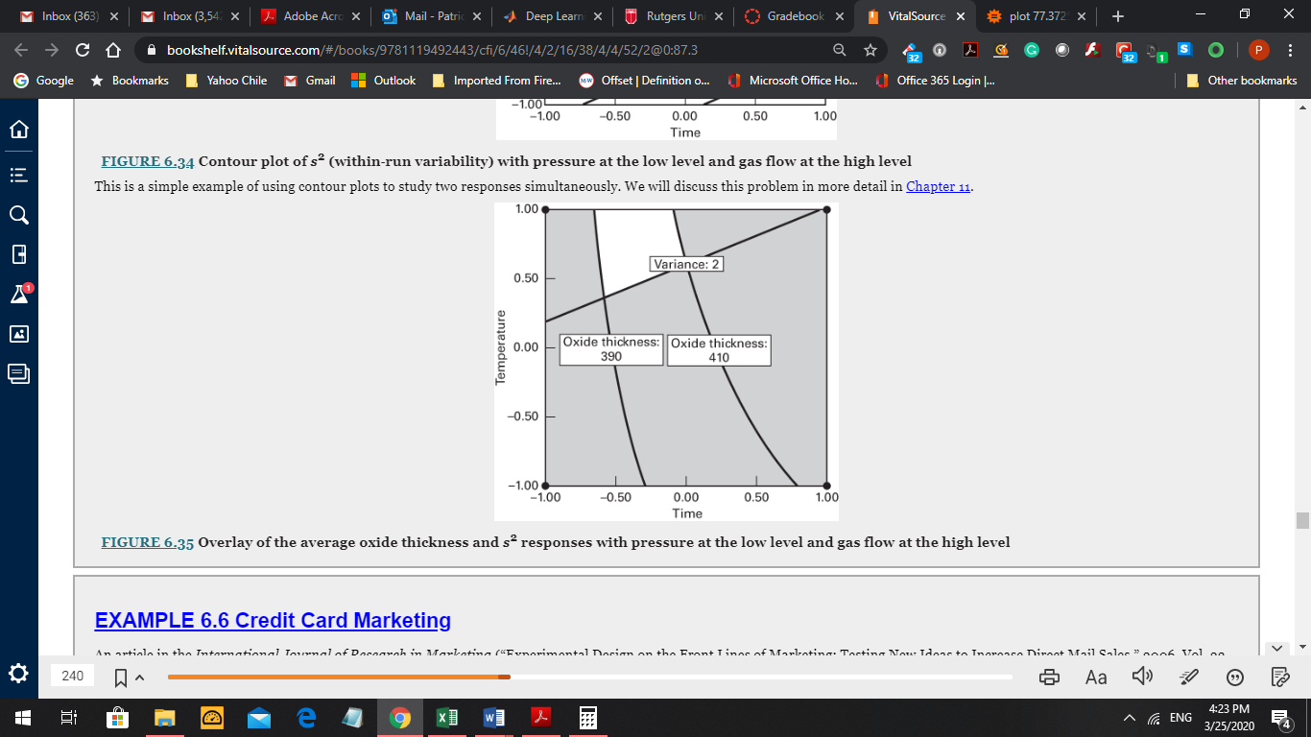

This is a very useful concept. Other special concept refers to optimality; here optimal estimator is the one with high precision, or lower variance. We will not cover this topic here.

One last topic to consider in a 2k experiment: adding other treatment combinations; for example the pair (0, 0) called center point. This points help to assess the possible curvature in the response.

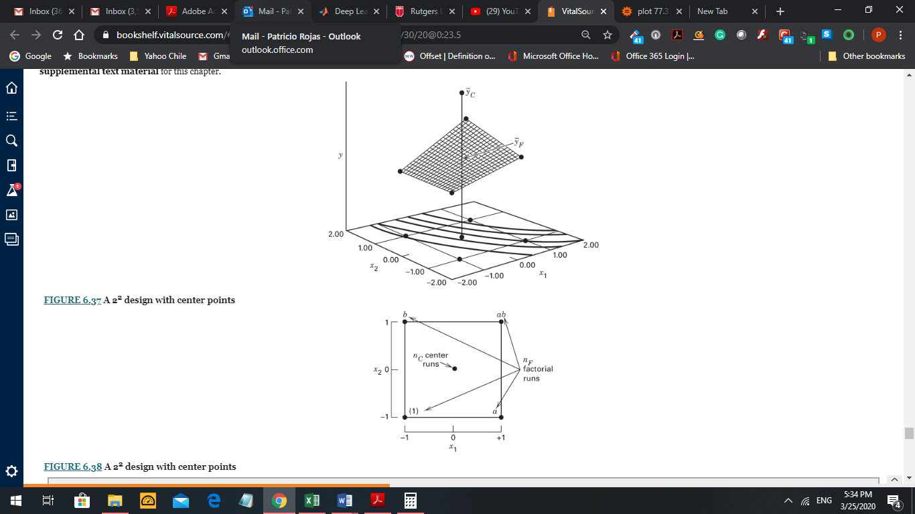

The most general regression model to study the presence of curvature is the second-order response model: (there is a misprint here; the factor of xj2 should be βjj instead of βij)

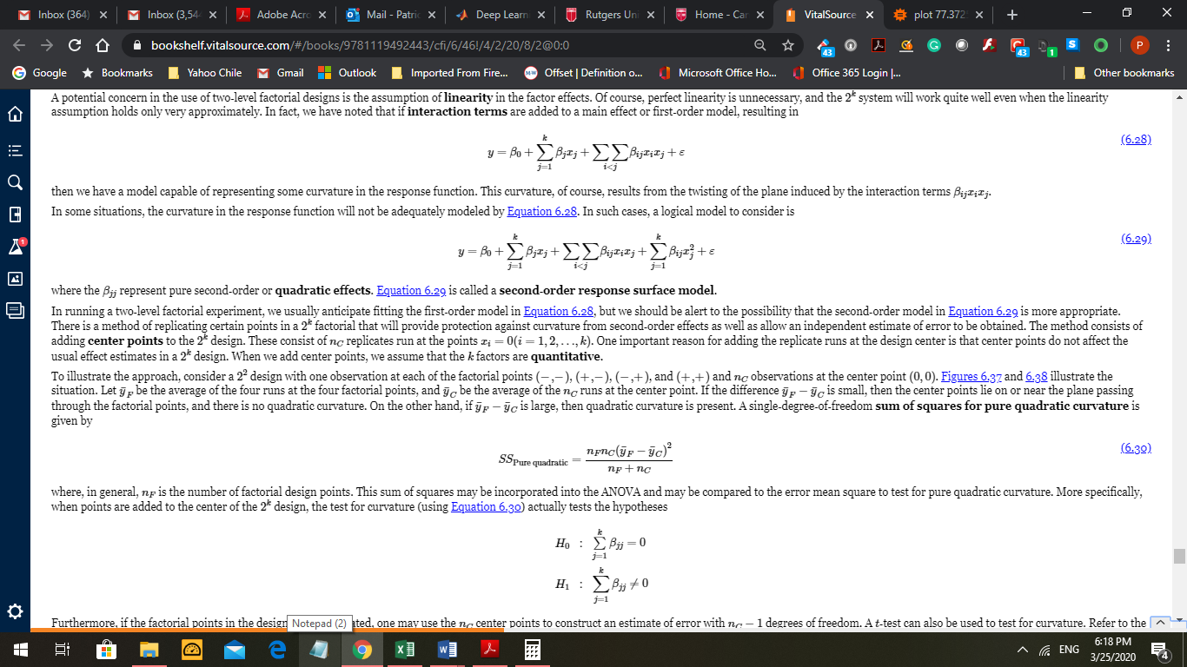(6.29)



Other points can be added to the design, as shown below. These are called Central Composite Design. Adding the axial runs (the points on the axis) gives more relevant information about the experiment.

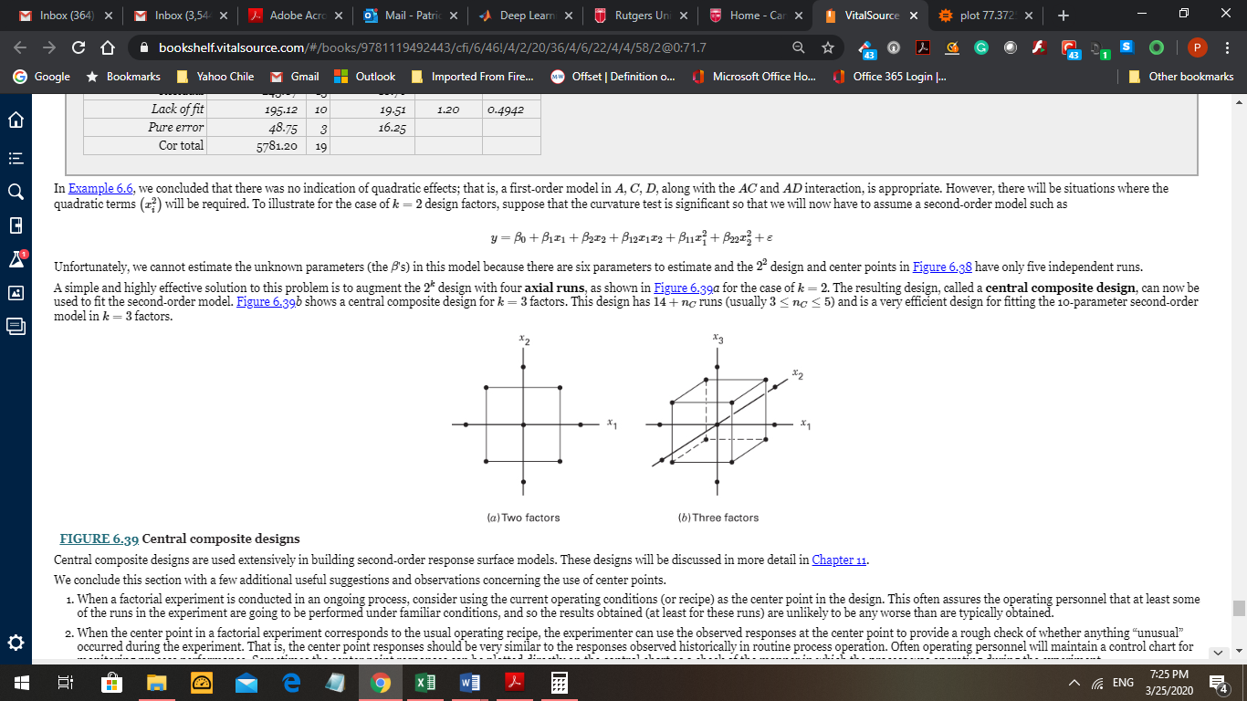

More about these topics will be covered later.

CHAPTER 7. Blocking and Cofounding in a 2k experiment.

We studied in Chapter 4 the concept of Blocking. This is one of the three basic ideas about a scientific experimental design (Randomization – Replications – Blocking). The idea of blocking is to create groups of more homogenous experimental units to compare the treatments with each block. The blocks can be complete or incomplete. Here is an example about using complete blocks in a 22n experiment, with n = 3, following the method introduced in Chapter 4 to reduce the SSE. The blocks correspond to the replications made from 3 different batch of raw material. The idea is to consider each batch as more homogenous to make comparisons between factors A and B.

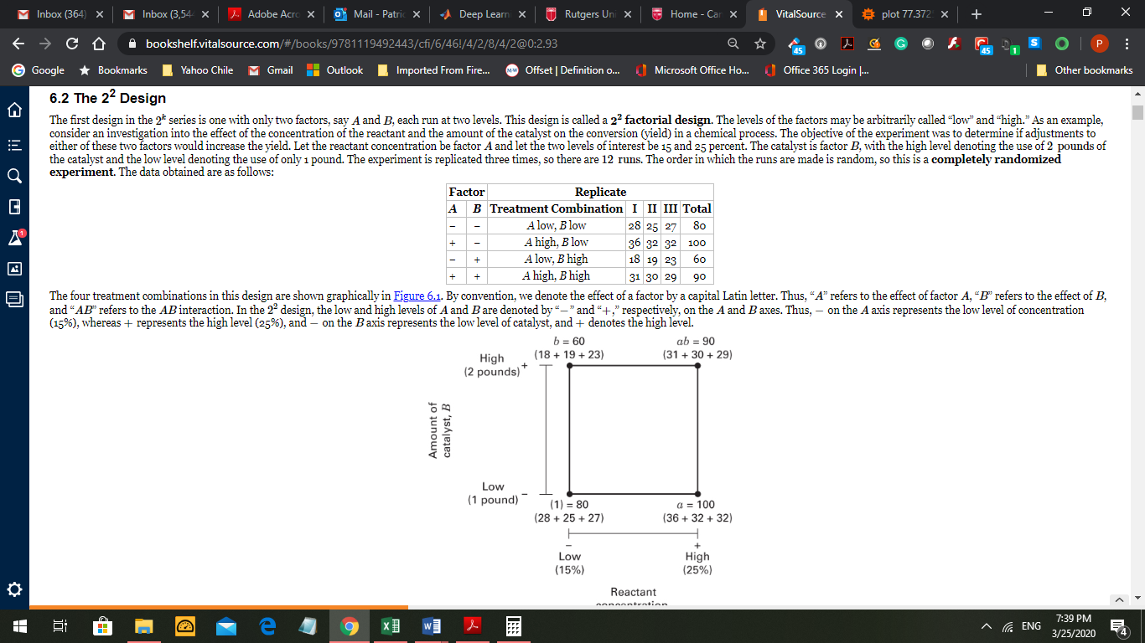

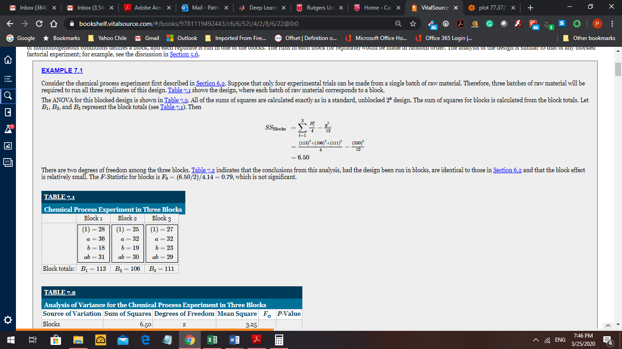

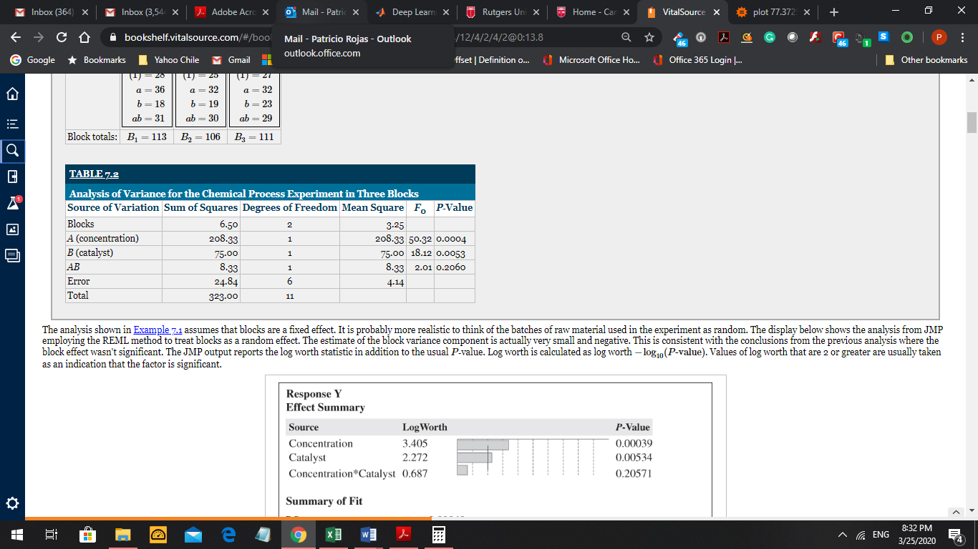

The main factors, concentration and catalyst appear as very significant, while the interaction is not significant. It is possible then to consider blocking on the interaction instead of the replications. This approach will be followed in this chapter. The interaction to select for blocking should be considered not important in the experiment. But now the blocks generated from a selected interaction will be incomplete. The analysis with incomplete blocks will be different than the one studied in Chapter 4. The design technique to create the blocks is called *confounding*. The term confound means that the interaction selected to create the blocks will have a sum of squares that will be indistinguishable from the sum of squares for the block effect. We will present two methods to confound an interaction with blocks: (a) the plus/minus sign, and (b) the defining contrast equation module 2. Obviously we never want to confound a main effect with blocks. Main effect information is too important to be lost in blocks effect. The interaction formed by many effects are preferred for confounding. In general we do not want to confound two-factor interactions.

(a) The plus/minus method to confound an interaction with blocks. Here we use the so called design matrix, that is, the columns with + and – (or +1 and -1). All the treatment combinations with the same sign in the column of the selected interaction, will form part of one of the blocks. The block that has the combination (1) is called the principal block. In the 22 design below we select to confound AB, and in the 23 design we select to confound ABC with blocks. Notice that the principal block is associated with -1 in the first design, and with +1 in the second design. We always generate 2 blocks when we confound one interaction with blocks. But we generate 4 blocks when we confound two different interactions with blocks. Similarly we generate 8 blocks when we confound 3 interactions with blocks. A general expression to explain this result is the equation 2k = 2k – p 2p where p = number of interactions to be confounded, 2p = number of blocks generated, and 2k – p the size of each block (that is, the number of treatment combinations it contains). We call 2k the original experimental design. Notice that the blocks are incomplete blocks.

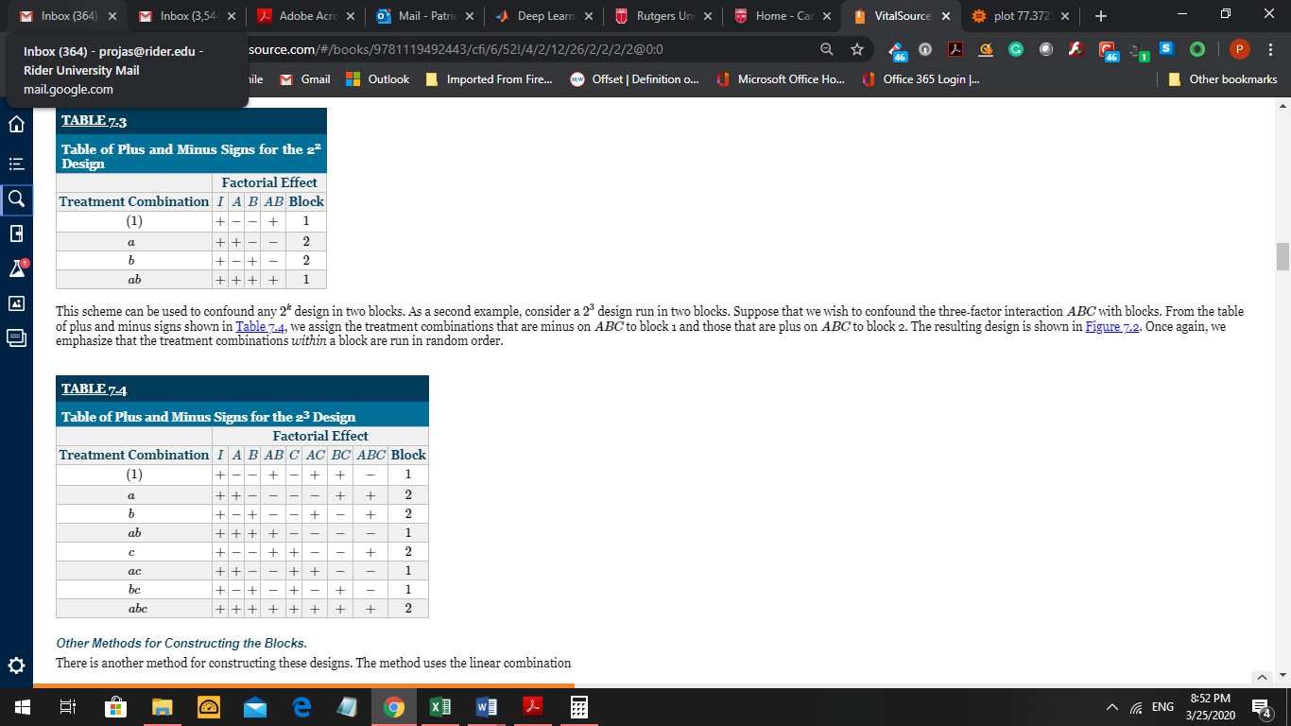

According to Table 7.3, the treatment combinations in the principal block, Block 1 are {(1), ab} and in Block 2 are {a, b}. There are 2 blocks each of size 2, since 22 = 22-1 21. The original experiment has 4

Table 7.4 shows that for a 23, the principal block, Block 1 is {(1), ab, ac, bc} and Block 2 is {a, b, c, abc}. There are 2 blocks each of size 4, since 23 = 23-1 21. The original experiment has 8 treatment combinations.

**Notice that *A* is different than *a*: *A* is the name of a main factor while *a* is the definition of a treatment combination that says use *A* at the high level and *B* at the low level as treatment combination. Another way to describe treatment combination *a* is to use the digits 1 and 0, that are the exponents of the expression *a =a1b0.* Similarly *bc = a0b1c1* can be represented by the digits 011. Since *c = a0b0c1* then we can use the digits 001 as the ‘label’ for the treatment combination *c*.**

(b) the defining contrast equation module 2 method. The linear equation, represented by L, needs to be solved by finding the unknowns that make the value of L equal to 0 or equal to 1, module 2. In Table 7.3, the equation L is xA + xB = 0 or 1 (mod 2). The variables xA and xB can take the values 0 or 1.

xA  xB xA + xB

0 0 0

1 0 1

0 1 1

1 1 2 ≡ 0 module 2 then Block 1 is {00, 11} and Block 2 is {10, 01}.

This notation using exponents can be changed to Block 1 = {(1), ab} and Block 2 = {a, b}.

The equation for Table 7.4 is xA + xB + xC = 0 or 1 (mod 2). The variables xA, xB and xC can take the values 0 or 1.

xA  xB xC xA + xB + xC

0 0 0 0

1 0 0 1

0 1 0 1

1 1 0 2 ≡ 0 module 2

0 0 1 1

1 0 1 2 ≡ 0 module 2

0 1 1 2 ≡ 0 module 2

1 1 1 3 ≡ 1 module 2

Then Block 1 is {000, 110, 101, 011} or {(1), ab, ac, bc}.

And Block 2 is {100, 010, 001, 111} or {a, b, c, abc}.

Notice that the columns with 0’s and 1’s follow the same sequence as the design matrix with –‘s and +’s (this is the standard order introduced by Frank Yates).

Suppose the interaction selected is BC instead of ABC. Then the equation and the blocks are as follows:

L is xB + xC = 0 or 1 (mod 2) and the solutions are

xA  xB xC xB + xC

0 0 0 0

1 0 0 0

0 1 0 1

1 1 0 1

0 0 1 1

1 0 1 1

0 1 1 2 ≡ 0 module 2

1 1 1 2 ≡ 0 module 2

Then Block 1 is {000, 100, 011, 111} or {(1), a, bc, abc}.

And Block 2 is {010, 110, 001, 101} or {b, ab, c, ac}.

This method can be easily done in Excel. See the Excel file “Confounding BC with blocks.xlsx” in Canvas (files).

Suppose you receive a principal block as follows and you need to get the other block (complementary block) without using the L equation. Simply multiply (module 2) the treatment combinations (or labels) in Block 1 by a label that it is not part of Block 1. Then you get Block 2. Example

Block 1 is {(1), b, ac, abc} then you multiply by a label that is not present in Block 1, say c. Then we have

Block 2 = {(1)*c, b*c, ac*c, abc*c} = {c, bc, ac2, abc2} = {(1), c, bc, a, ab} since c2 = c0 = 1 (mod 2).

(Which interaction was confounded in the case?).

Replications are needed in a 23 design to estimate the error with more certainty.

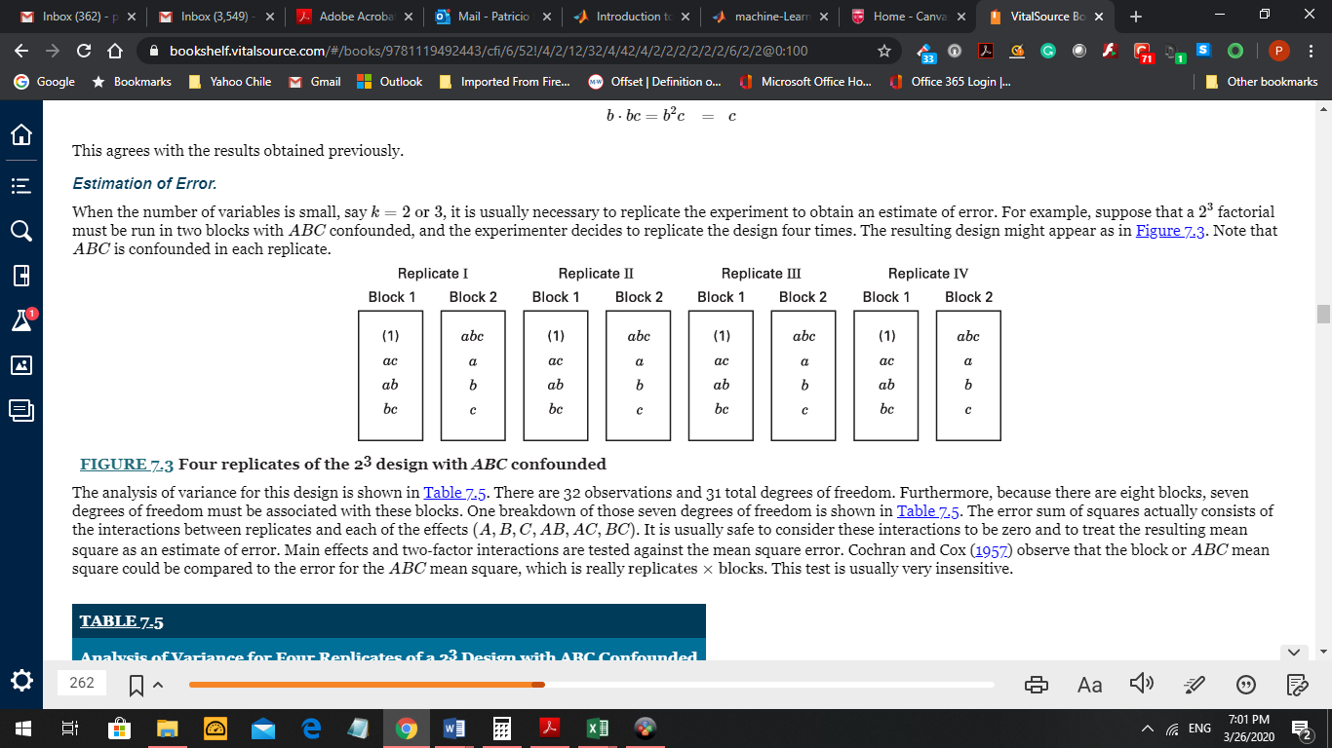

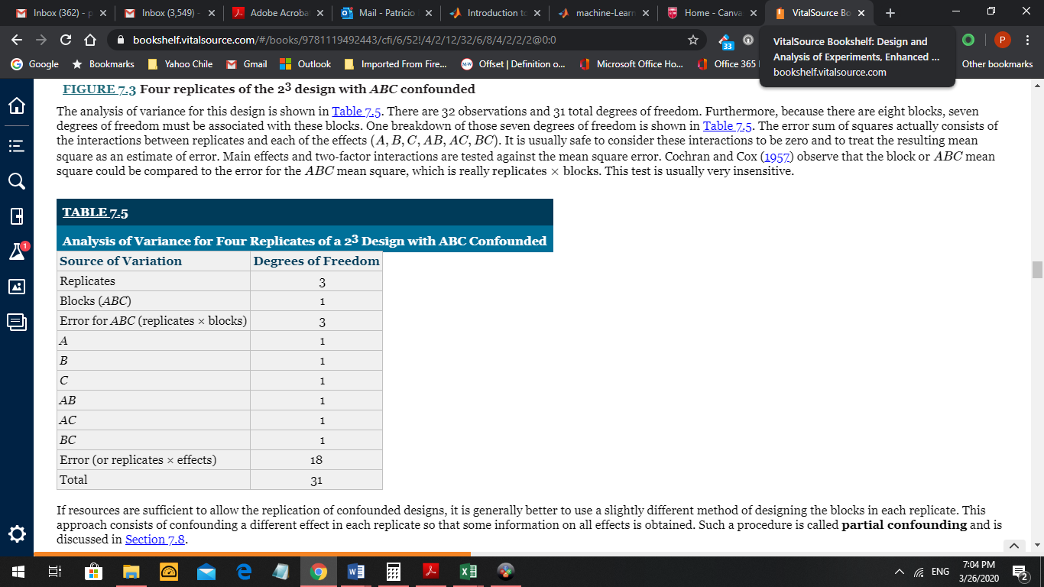

Example of a 24 design, with factors A, B, C, and D. The ABCD interaction will be confounded with Blocks:

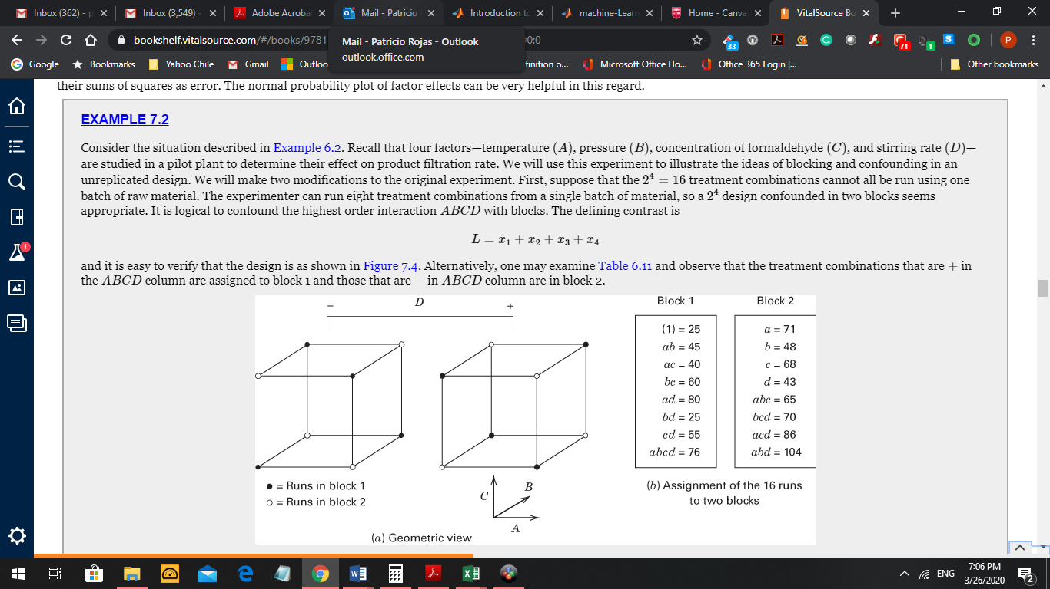

You can verify some of these results.

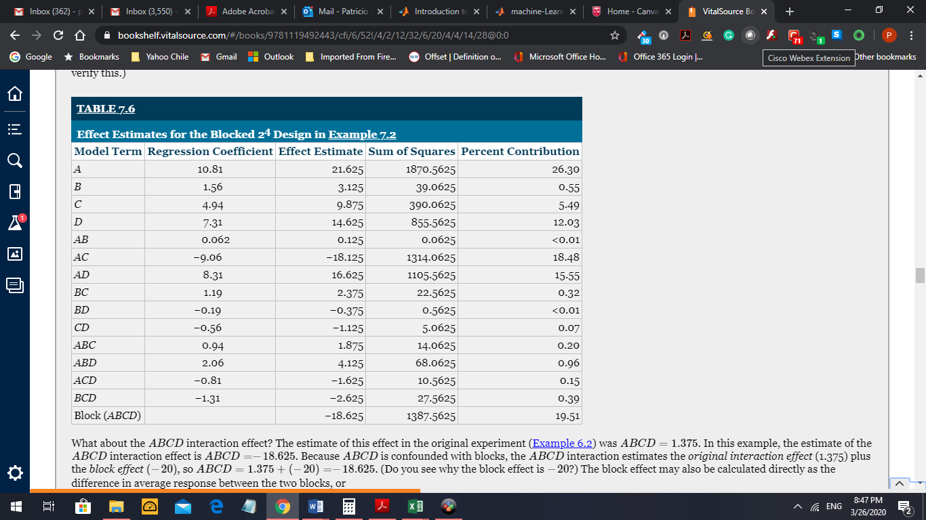

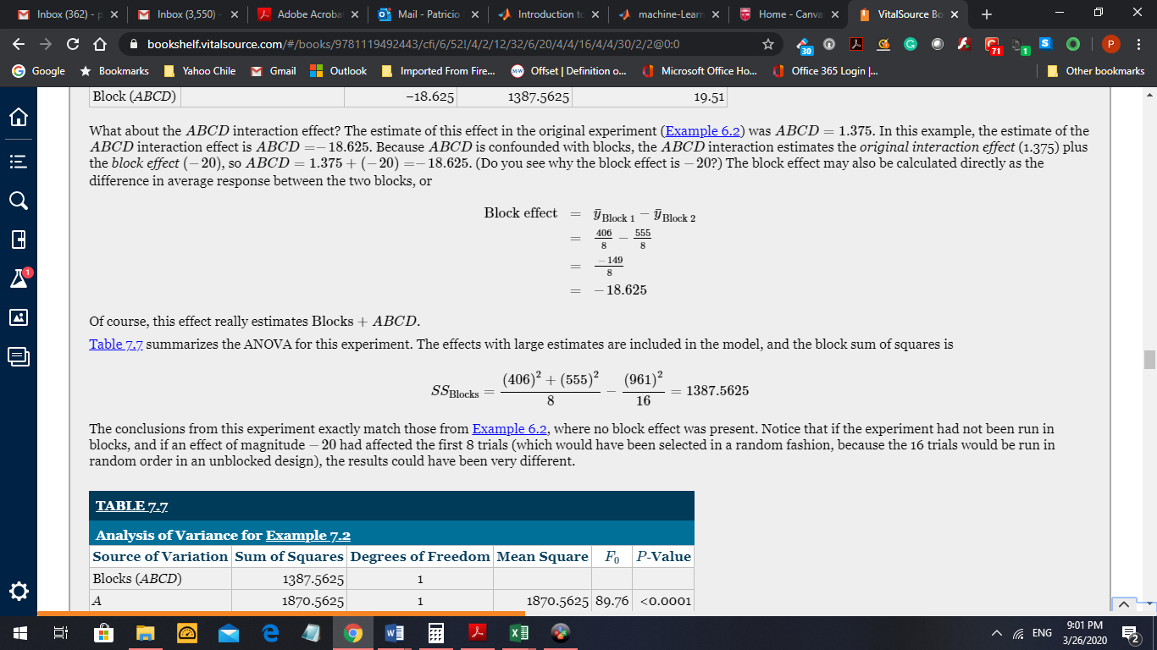

The ANOVA table below show all the effects are significant.

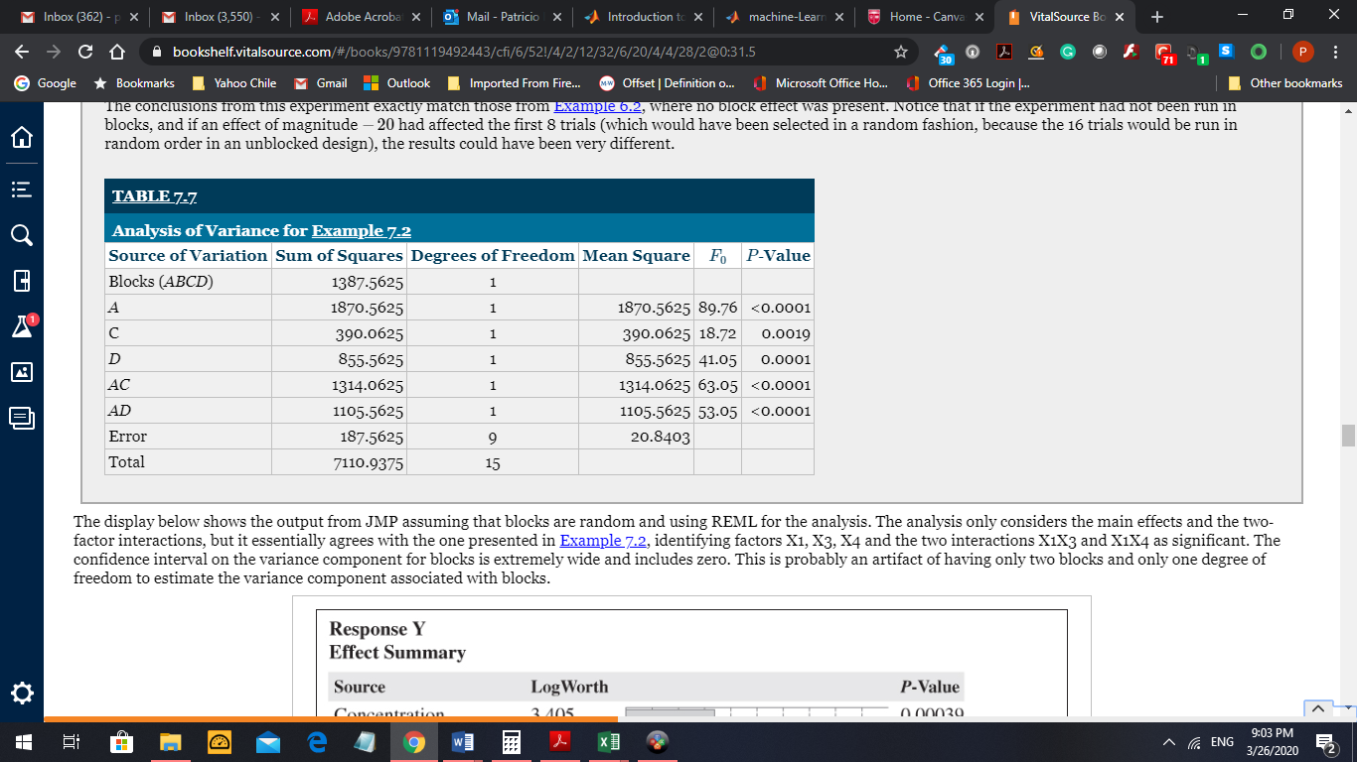

Confounding 2 interactions in a 25 design generates 4 blocks of size 8 each one: 25 = 25-222

Confounding ADE and BCE. Two interactions produce a generalized interaction ADE*BCE = ABCD

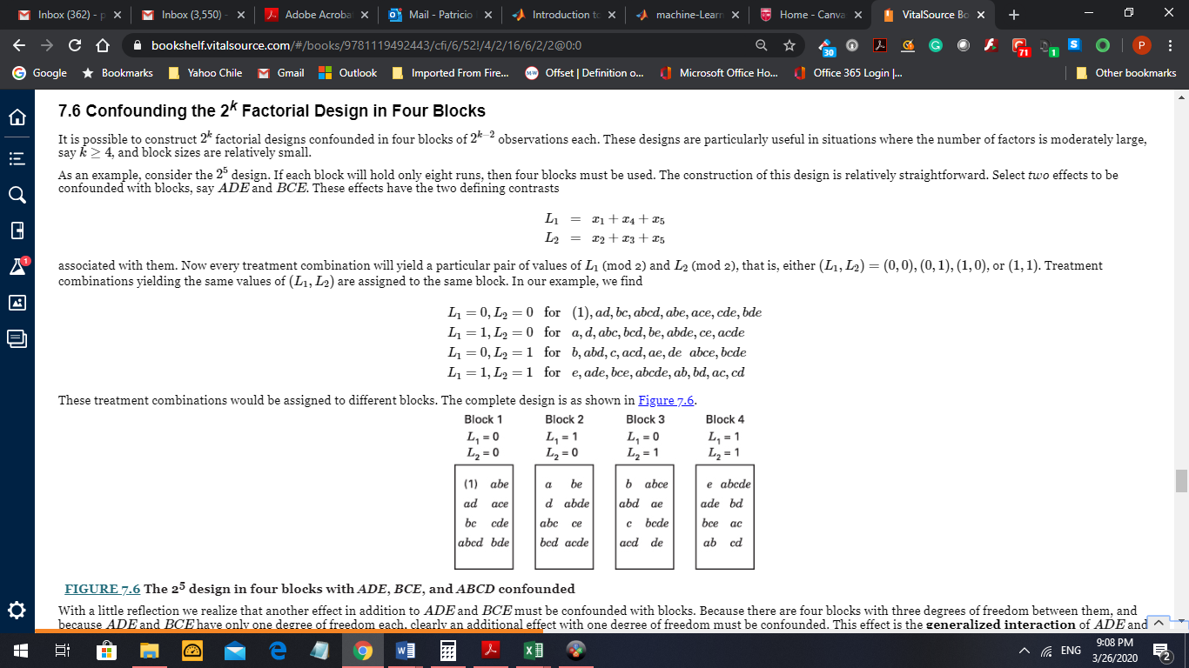

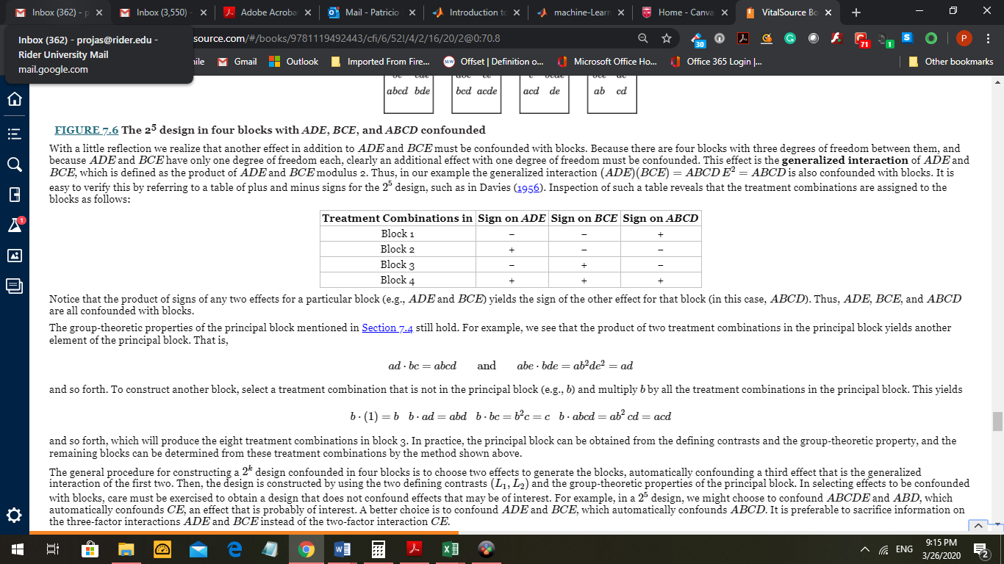

The following Table 7.9 helps to choose what to confound, to avoid selecting interactions that may produce generalized interactions that we want to avoid. For example in a 26 design with factors A, B, C, D, E, F it would not be convenient to confound ABEF, ABDE, and CDF. We will get C confounded with blocks. The generalized interactions appear by multiplying in pairs and then the three interactions.

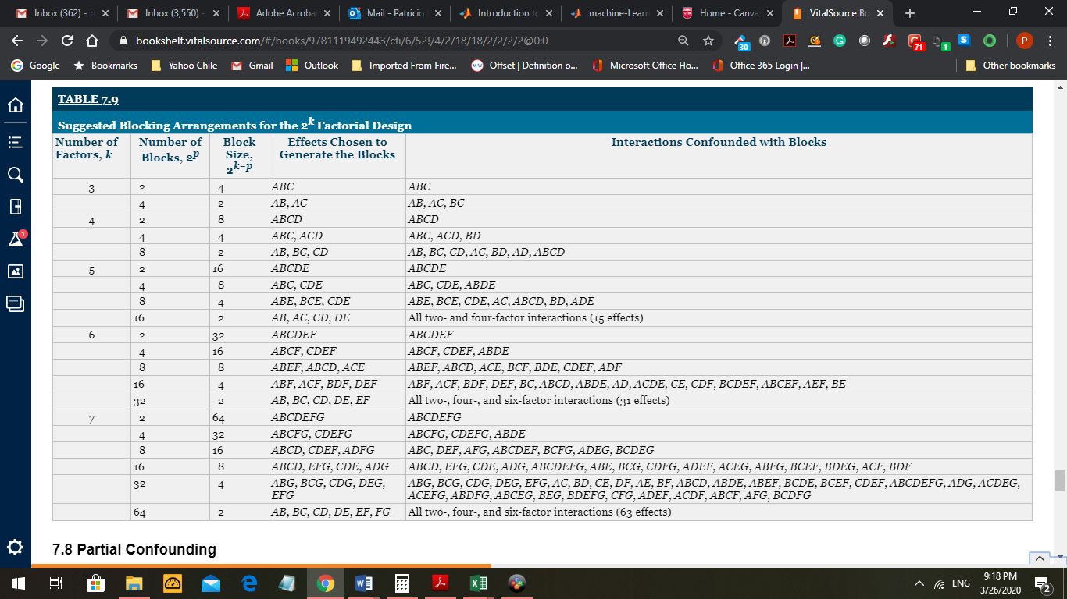

Once an interaction is confounded its information is lost. Using Partial Confounding you can recover that information.

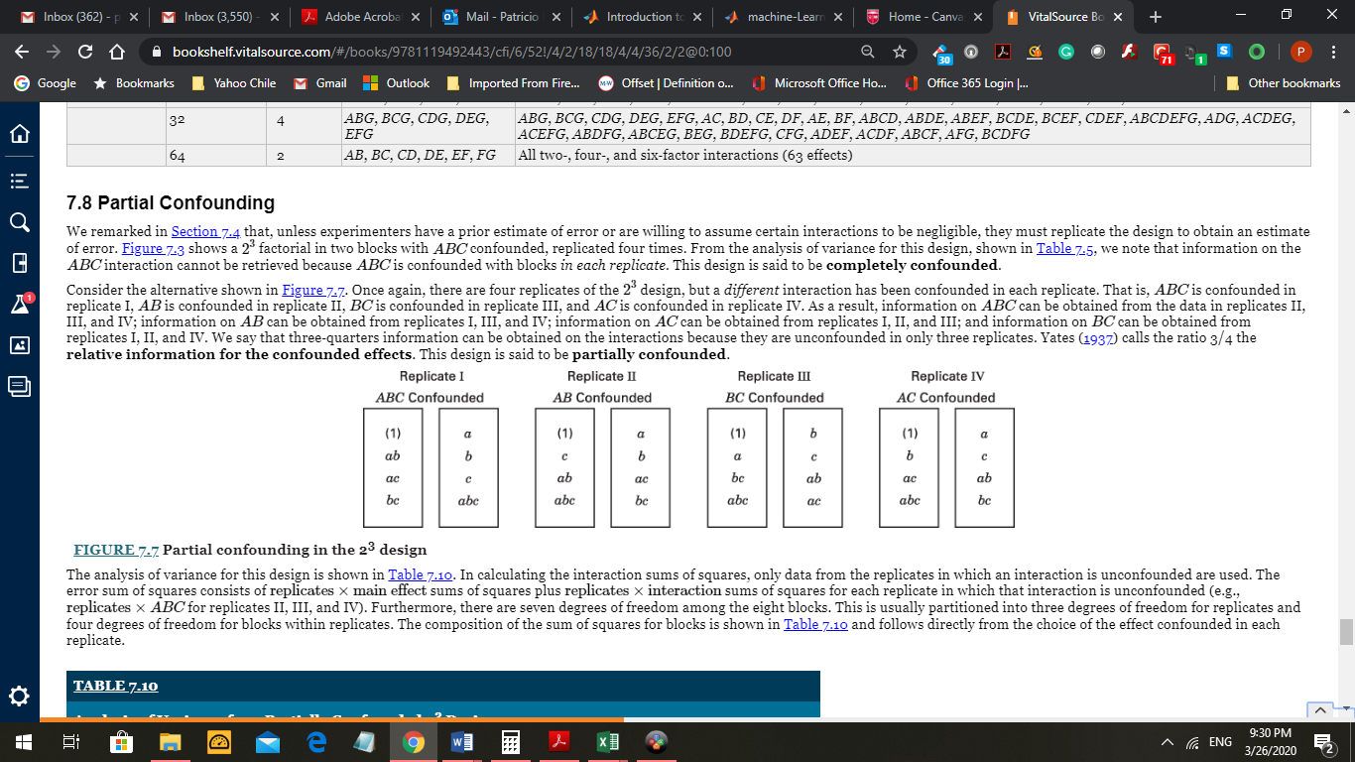

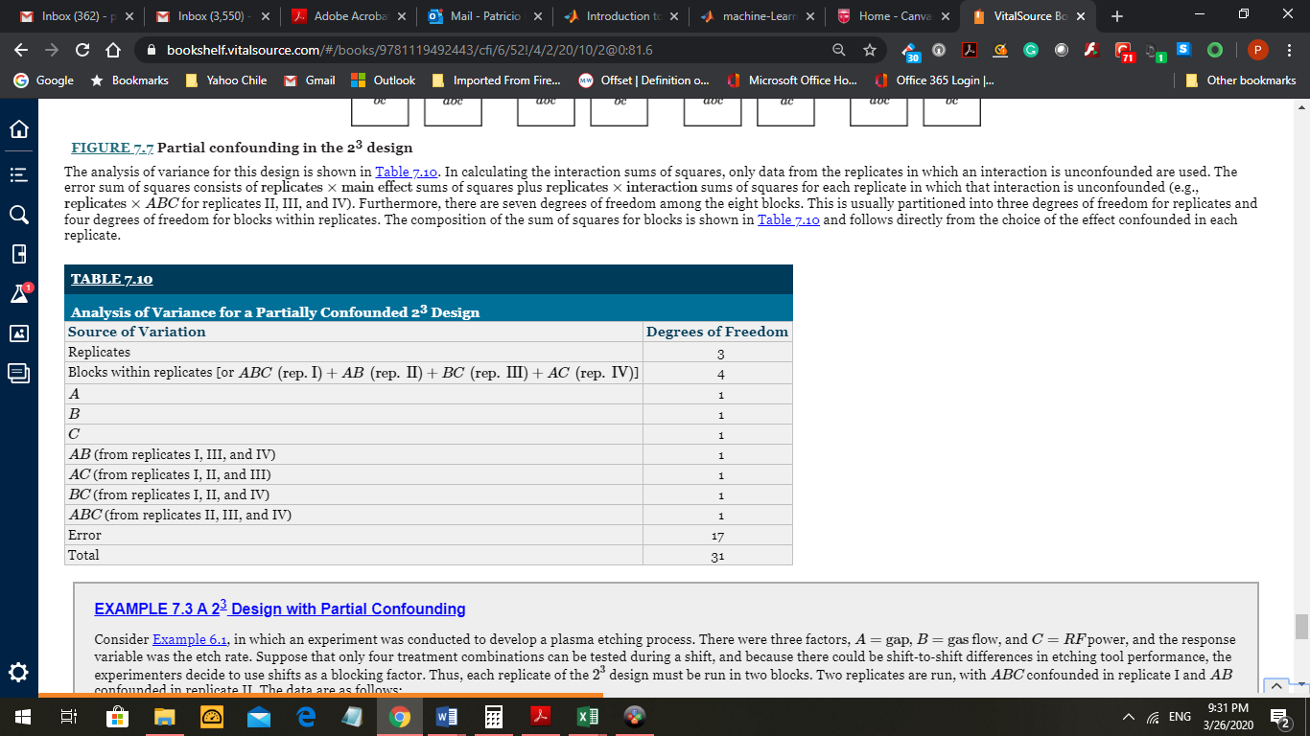

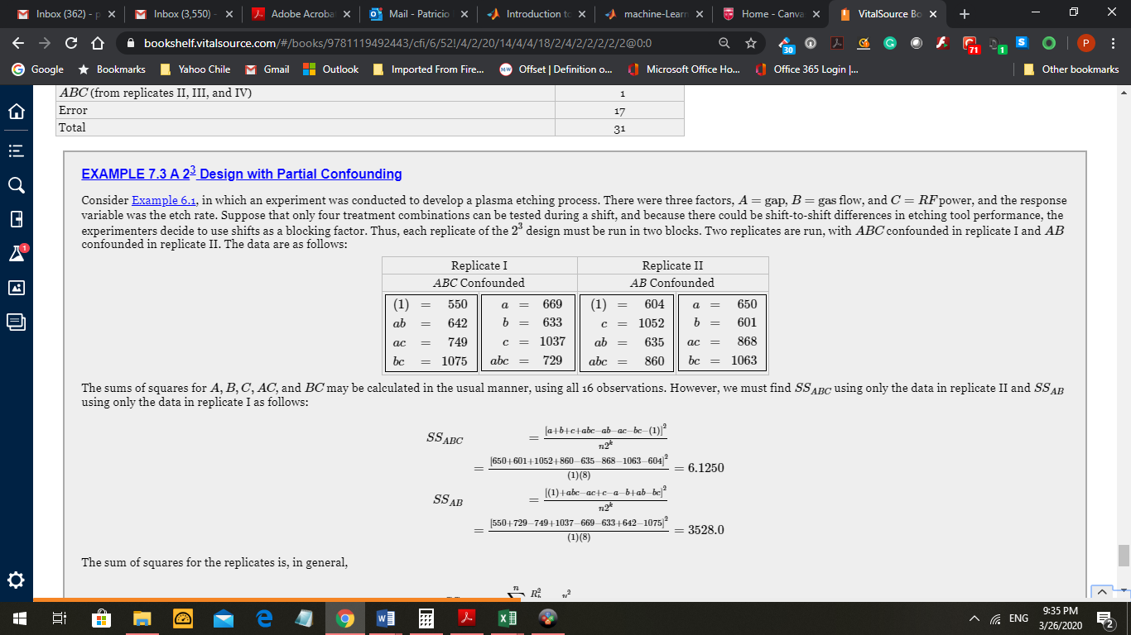

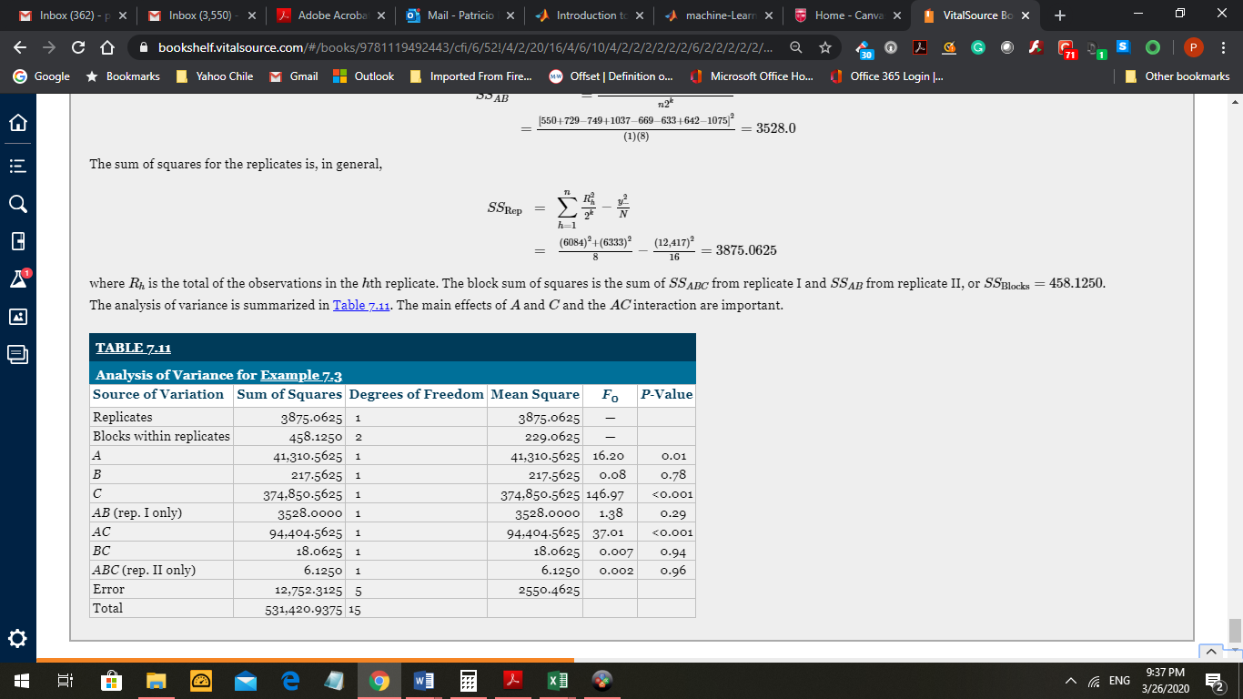

I will add another Homework in Canvas.

Next Chapter is # 8, Two Levels Fractional Factorial Designs.